***This document is open for feedback and inputs. Please add your feedback / input via Comments***

1. CONTEXT 1

2. PACT CONFORMANCE TESTING OVERVIEW 1

2.1 What is the focus and scope of PACT conformance testing? 2

2.2. When does a host system under test satisfy a PACT conformance test? 3

2.3 What is not yet in scope of the PACT conformance testing? 3

3. CONNECTATHONS 3

3.1 Connectathon Process 4

4. CONDUCTING A PACT CONFORMANCE TESTING 5

4.1 Process 5

4.2 PACT Conformance Test criteria (Checklist) 7

5. ONBOARDING A SOLUTION TO PACT ONLINE CATALOG 7

5.1 Process to Submit a Solution in Online Catalog 8

6. FAQs 11

7. Appendix 14

7.1 Pathfinder Technical Specifications 14

7.2 PACT Online Catalog 14

7.3 Publish Conformance Test Results to PACT Online Catalog 14

# 

# **CONTEXT**

The [Partnership for Carbon Transparency](https://www.carbon-transparency.com/) (PACT) initiative is continuously evolving and bringing together organizations and industry initiatives to exchange accurate and primary data-based Product (Carbon) Footprints irrespective of geography and industry. The technical foundation for this exchange is currently the **Pathfinder Framework** and **Technical Specifications** for achieving interoperability.

If a company wants to exchange Product Footprint information in a truly interoperable way, it then either needs to implement these foundations or look for an existing solution.

In both cases, companies need to be able to assess the **conformance** of their software and solutions.

This document defines the overall process of testing the conformance of software implementations, and the requirements for having a solution listed publicly online on the **PACT Online Catalog**.

# **PACT CONFORMANCE TESTING OVERVIEW**

Conformance testing is a process of verifying if a product or service meets specific standards or specifications. In the context of PACT this is the process of verifying that a solution or system implements the [**Pathfinder Framework**](https://www.carbon-transparency.com/media/b13h4b25/pathfinder-framework_report_final.pdf) and technical specifications.

As the technical and solution landscape in the PACT context is rapidly evolving, in a first step a very “**lean”** and **minimal process** is defined. This process will evolve further in scope and complexity, and include software-based automation in the future.

**Example: What is a PACT conformant solution?**

A PACT conformant solution “A” is defined as a solution which:

* Was **tested for conformity with a specific version of the technical specifications** with **2 or more other solutions**
* Where the other solutions **independently confirm** the conformance of solution “A”

### **2.1 What is the focus and scope of PACT conformance testing?**

 The PACT Conformance testing process focuses on testing the **technical interoperability** of a specific implementation (called “host system under test”):

1. **Technical interoperability testing is scoped by data exchange protocol version:** an implementation is tested for conformance against a ***specific* version** of the data exchange protocol (such as [version 1.0.1](https://wbcsd.github.io/data-exchange-protocol/) or a later version such as [version 2](https://wbcsd.github.io/data-exchange-protocol/v2/)) by a 3rd party.
2. **Technical interoperability testing focuses on the HTTP REST API:** for this, the 3rd party makes conforming calls to the HTTP REST API of the host system under test. The 3rd party then compares the witnessed behavior with respective specification.
3. **Optionally,** technical interoperability testing covers **interoperability testing of a data model extension**: for this, the parties test technical interoperability **against a specific data model extension version**. If the data model extension provides instructions for doing so, the testing process shall cover them.

### **2.2. When does a host system under test satisfy a PACT conformance test?**

A host system under test has satisfied a PACT conformance test **if the 3rd party declares it has performed a PACT conformance test with the host system under test, and that the behaviour of the host system under test was conforming to the specification** (see e.g. Section 4.2 of this document for a checklist)**.**

### **2.3 What is *not yet* in scope of the PACT conformance testing?**

For the first iteration of the Conformance Testing - testing of conformance with the Pathfinder Framework, GHG Protocol (likewise ISO 14044 etc.), sector-specific or product-specific rules **is *not* in scope.**.

 The first iteration of Conformance Testing will validate solutions conform to the PACT **technical specifications only**. Solutions will not be assessed for conformance to Product Carbon Footprint methodologies, such as Pathfinder Framework, GHG Protocol (likewise ISO 14044 etc.), sector-specific or product-specific methodologies.

**Example**: if a host system under test implements the HTTP REST API but contains a (critical) bug in its GHG protocol implementation, the solution would ***still* meet the PACT conformance** testing requirements.

Note: Future definitions of the conformance testing process will **extend** their scope.

# **CONNECTATHONS**

A Connectathon is an event organized by WBCSD PACT. It is geared towards **simplifying** **interoperability** and **conformance** testing between implementers and their respective solutions.

A Connectathon is open for invited parties and logically consists of

* **Key Date** when the Connectathon takes place and collaboration starts
* List of companies **participating**
* Dedicated **MS Teams channel** to collaborate and share feedback, test progress, and outcome

### **3.1 Connectathon Process**

Organizations can Onboard their Solution to PACT Online Catalog before / or after the Connectathon.

Please refer the process below -

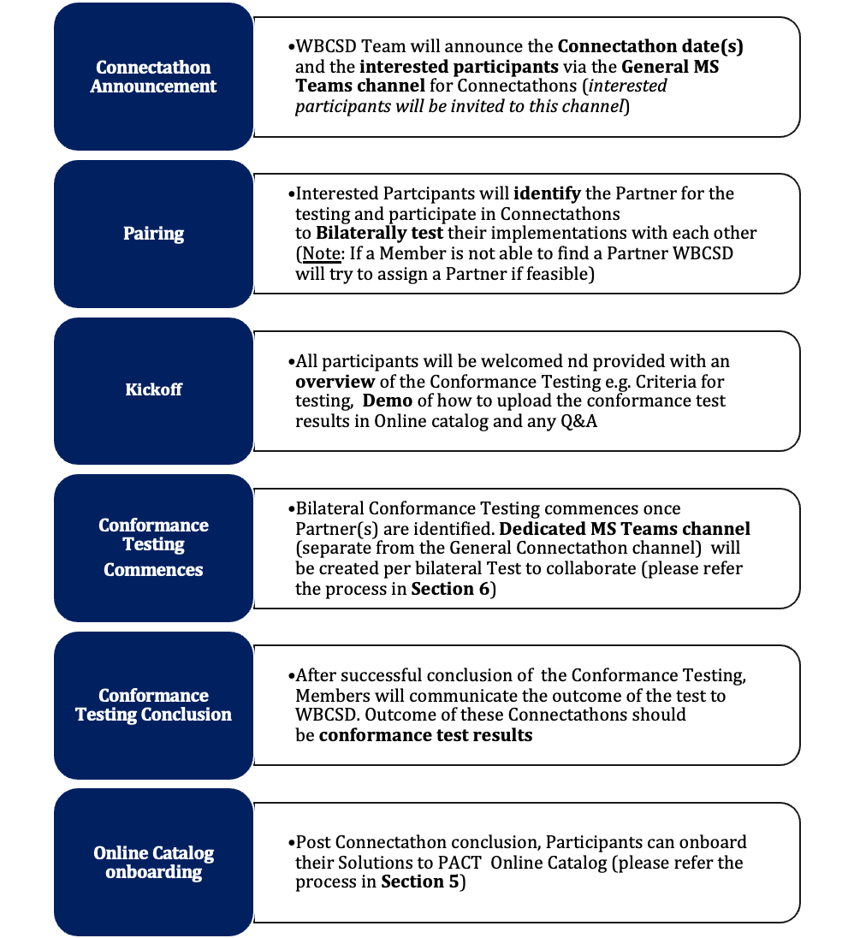

***Connectathons will be conducted on a Monthly basis***

***First Connectathon is tentatively planned for 3rd week of April***

# **CONDUCTING A PACT CONFORMANCE TESTING**

Conformance Testing commences once Organizations identify their Testing partner(s) before or during Connectathons.

### **4.1 Process**

The key stages of a PACT Conformance Test performed by the parties are depicted below:

**Test**

**Share Results**

**Publish Results to Online Catalog**

Conduct Conformance testing as per PACT Test Criteria and Checklist for conformance

Align on Timeline, Process, and communication mechanism

Setup Test Plan, Test Data, and Test Environment

Verify the conformance of the solution as per PACT

Report issues/queries bi-laterally

Results of the testing are shared bi-laterally and with WBCSD. The results should capture the details of the test performed and the alignment with PACT Conformance testing criteria

Optionally publish the Test Results to Online Catalog

* Organizations will **Initiate** the Conformance Testing process by aligning on Timeline, Process, and Communication mechanism (dedicated Private MS Teams Channel).
* Conformance **Test** begins based on the Test Data / Environment setup initially. It is assumed, the parties perform the testing in accordance with the PACT Criteria Checklist for the testing. The parties are free to use Teams or different channels during the Connectathon or after. Additionally, the parties are free to use the PACT-sponsored SharePoint to share data among each other.
* Organizations will continuously / iteratively run test scenarios and **evaluate** the PCF Data exchange as per the PACT Conformance testing criteria Checklist. Issues / queries can be posted and resolved via the MS Teams Channel. After successful conclusion of a conformance test, Organizations will **Sign Off** the Solutions (Pass/Fail)
  + Organizations are encouraged to **retest** their solutions during the next scheduled **Connectathon**, especially in case when issues have been resolved or support for new versions (related to the data exchange protocol or 1 or more data model extensions) was added to a previously-tested implementation
  + Organizations are encouraged to onboard their solution to the PACT Catalog and to upload conformance results there as well (see [here](https://github.com/sine-fdn/pact-catalog/blob/main/CONTRIB_SOLUTION.md#6-create-a-new-json-file-in-the-conformance-tests-directory) for details)
* The Conformance Testing process is **periodically** **reviewed, updated,** **and scope expanded** (see section 2.3)to reflect changes in the organization's standards and requirements, as well as feedback received from members of the network.

### **4.2 PACT Conformance Test criteria (Checklist)**

Recommendation from WBCSD to be used as a reference for the Bilateral Conformance Testing criteria for TechnicalInteroperability. A Solution is deemed PACT Conformant if it meets all the criteria’s as defined in [this checklist](https://wbcsd.sharepoint.com/:w:/r/sites/ClimateEnergy/_layouts/15/Doc.aspx?sourcedoc=%7BA7E31E83-455A-43F0-B7C1-81AF133A3B60%7D&file=2023-03-20-PACT%20Tech%20Spec%20V2%20Conformance%20Testing%20Checklist_vDraft.docx&action=default&mobileredirect=true) -

# **ONBOARDING A SOLUTION TO PACT ONLINE CATALOG**

Companies can onboard their Solutions to PACT Online Catalog at any time – **regardless if their Solutions were tested for Conformance** or **not tested** yet. Depending on whether the Solution was Conformance tested or not, the Status of the Solution in the PACT Online Catalog will reflect accordingly once they are onboarded to it. Please Refer below -

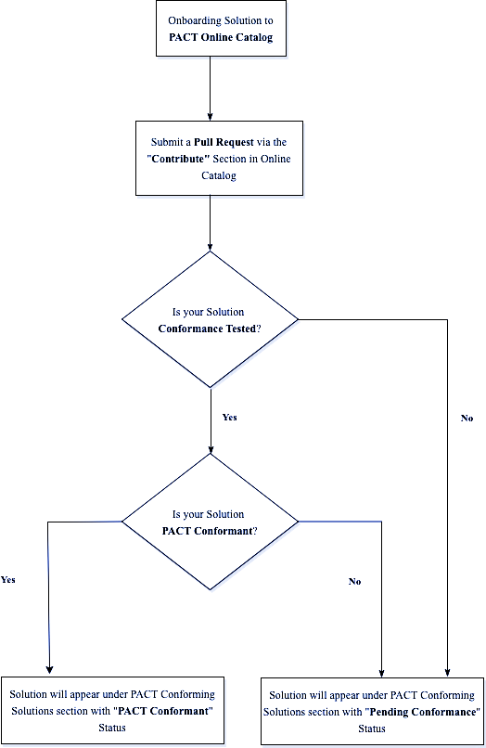

### **5.1 Process to Submit a Solution in Online Catalog**

1. Navigate to the “[**Contribute**](https://pact-catalog.sine.dev/contribute)” section

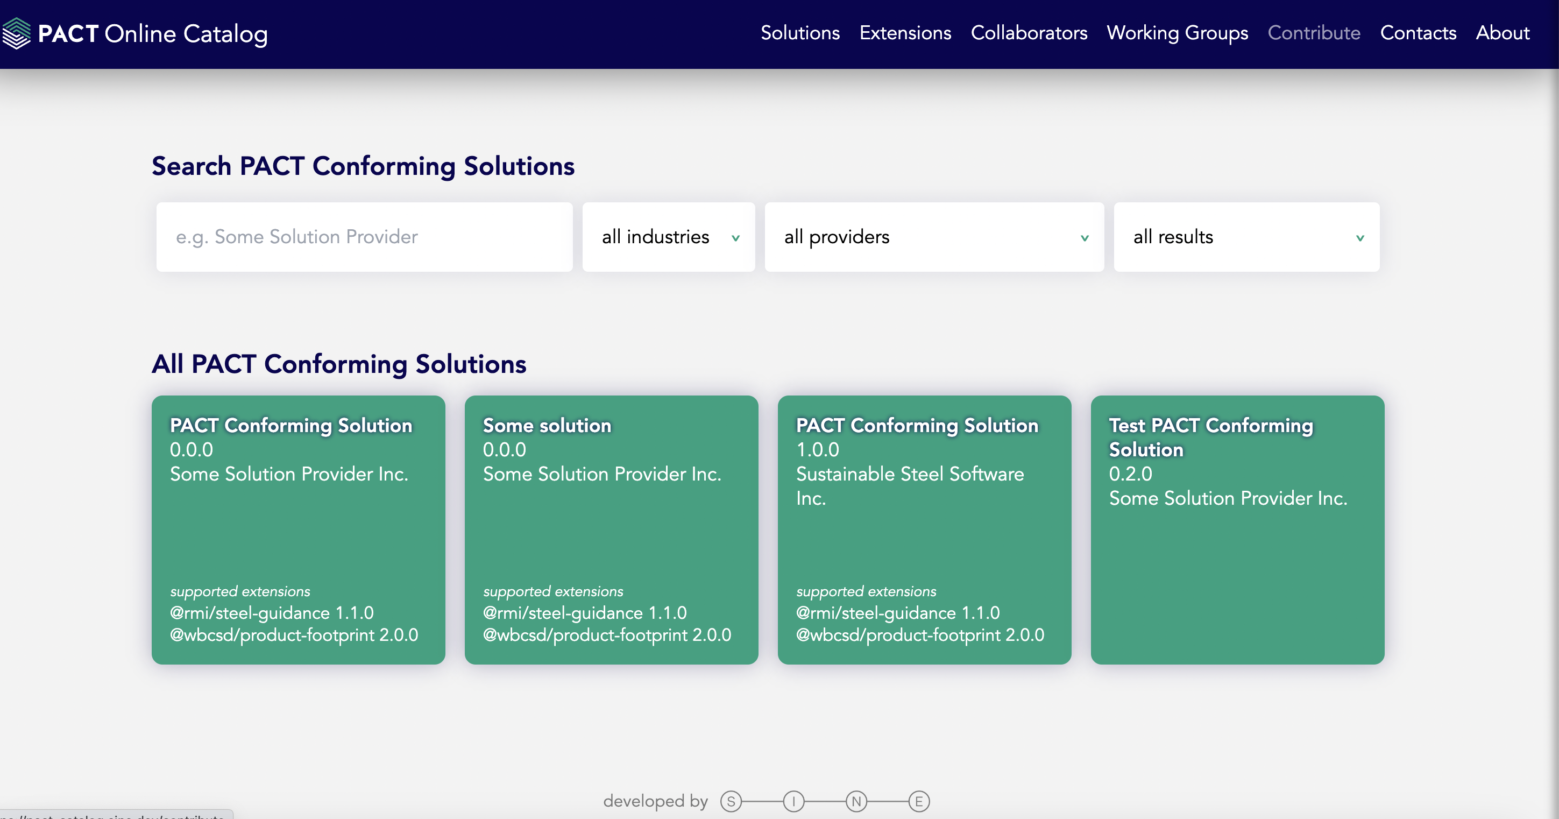

1. Click the “**Go to GitHub**” button under the “Solution Provider?” option

* You will be taken directly to the [WBCSD PACT Online Catalog repo](https://github.com/sine-fdn/pact-catalog/blob/main/CONTRIB_SOLUTION.md).
* Follow the process as described in the **CONTRIB_SOLUTION.md** to

Submit a Pull Request (PR) for your Solution

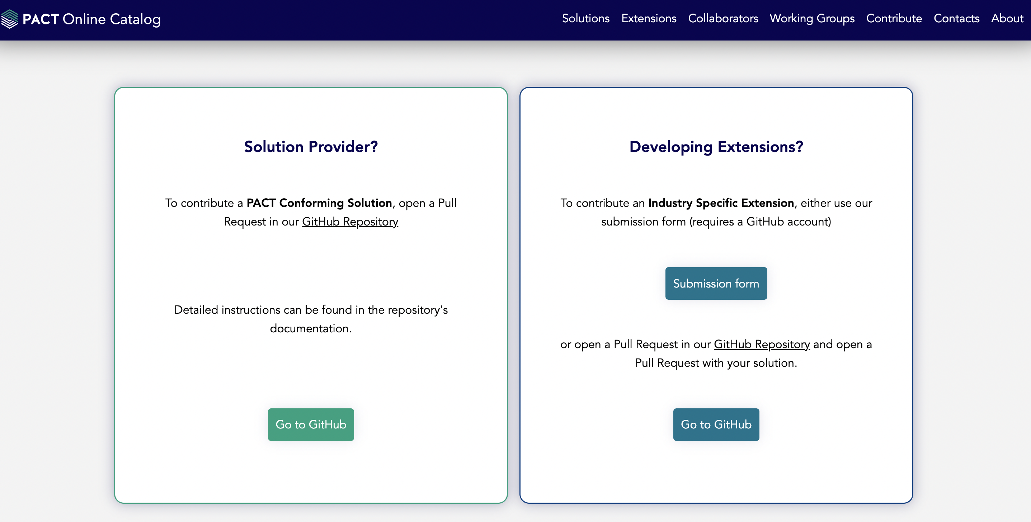

* Once the Pull Request is submitted (above step), the Pull Request will be reviewed for completeness. If all details are filled out correctly, the PR will be merged and the Conforming Solution will appear under the “[Solutions](https://pact-catalog.sine.dev/solutions)” page on the Online Catalog

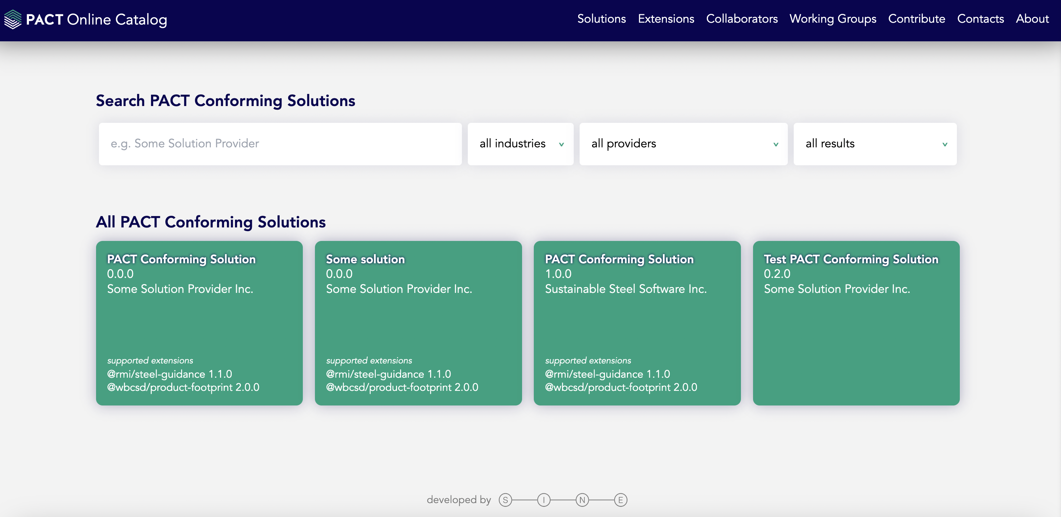

* After clicking a particular “Conforming Solution”, you will be taken to the Details page (example below)

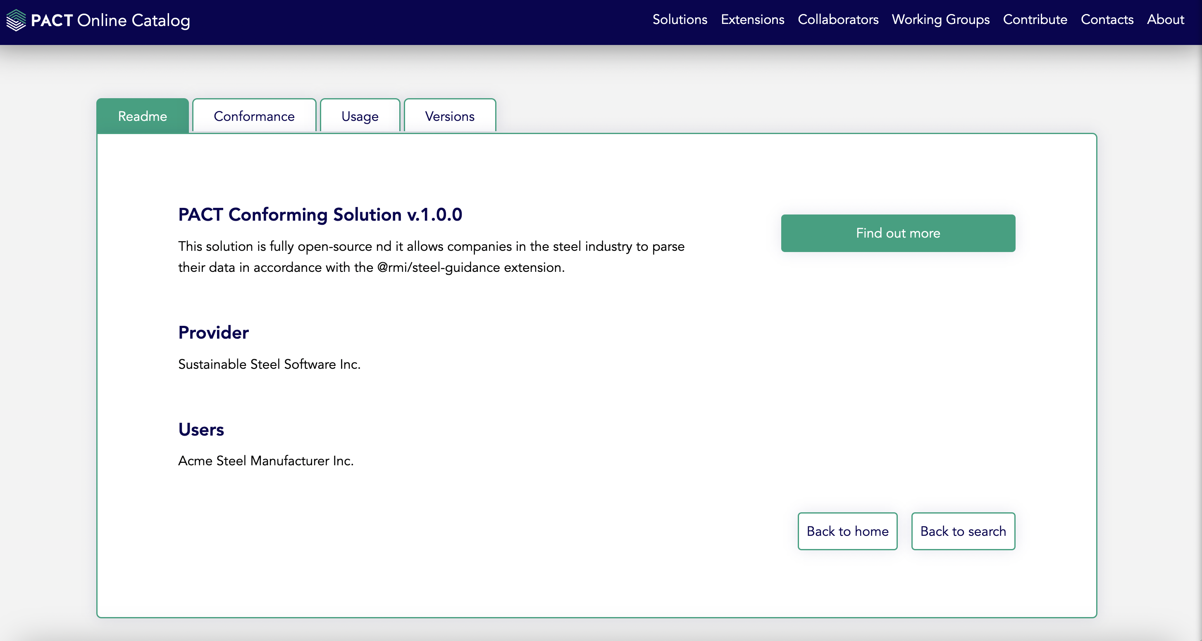

* You can review the details of all your Conformance Tests under the “**Conformance**” tab

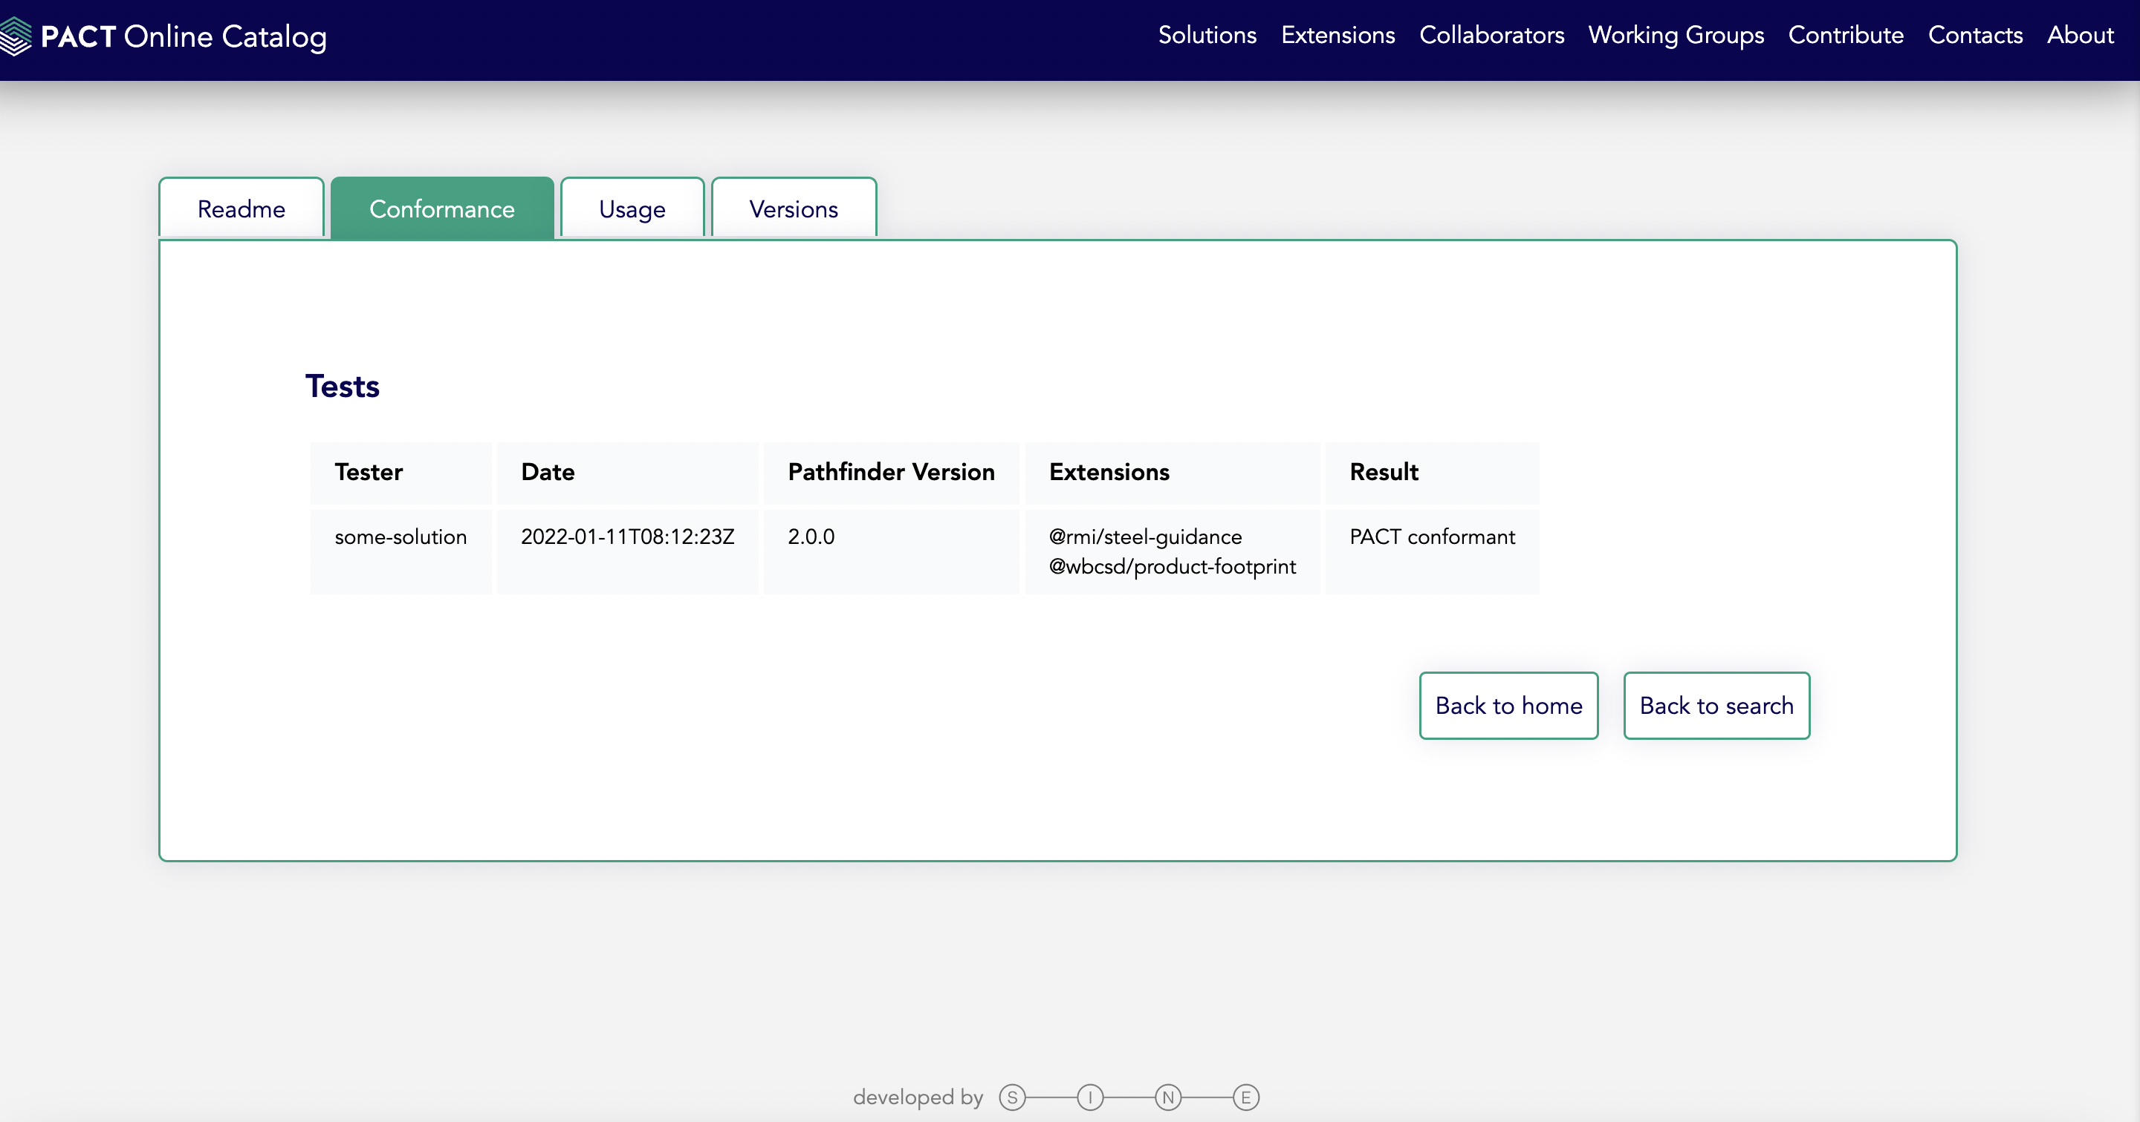

# FAQs

**Q: Our Solution is not yet fully ready but we would still like to participate in the Connectathon and the Conformance Testing process?**

**A:** Yes, Organizations are welcomed and encouraged to participate in the Connectathon and the Conformance Testing process even if their Solution is not fully ready

**Q: Our Solution is ready and based on Technical Specification V1. Can we still participate in the Connectathon and the Conformance Testing process?**

**A:** Yes, Organizations are welcomed and encouraged to participate in the Connectathon and the Conformance Testing process for their Solution Conformance to any Version of the Technical Specification. The Conformance against a particular will reflect accordingly in the Online Catalog

**Q: Do participants need to identify a partner BEFORE the Connectathon kickoff?**

**A:** PACT Team will conduct a Kickoff before every Connectathon which will cover – Overview of the Conformance Testing Process, Introduction of the participants, Logistics (MS Teams channel, Communication / collaboration mechanisms between testing partners), Demo of the Online Catalog and How to add Conformance Test Results and Solution to the Catalog, and any Q&A. Participants can decide during this kickoff or post Kickoff who they want to collaborate with for the Conformance Testing

**Q: What are the pre-requisites for participating in the Connectathons?**

**A:** The main pre-requisites for participating in the Connectathons is that you have a Solution (fully ready or partially ready) that follows Technical Specification V1 or V2

**Q: Is there a limit on the Testing Partners an Organizations can conduct Conformance Testing with during the Connectathons?**

**A:** Organizations are welcomed and encouraged to pair-up with multiple Partners who are available for Testing. Note: Minimum **2** independent Organizations need to conform the Solution for the Solution to be deemed PACT Conformant

**Q: How many times can we offer up our solution to be tested in Connectathons?/How many Connectathons can we participate in?**

**A:** Organizations are welcomed and encouraged to participate in multiple Connectathons and conduct multiple Conformance tests within a Connectathon.

**Q: Is there a component of "learning" as part of Connectathons?**

**A:** Once the conformance Testing is concluded, Organizations are recommended to share the Test Results and the **observations**. (In the format they choose to). These observations can be leveraged as learning opportunities. PACT Team will also plan on organizing **Retrospective** sessions after a Connectathon is concluded, so that Organizations who participate in the Connectathons and conformance testing can share their experience and learning.

**Q: Our Solution passed the Conformance Tests during a Connectathon. Can we still participate in any upcoming Connectathon?**

**A:** Yes you can participate in any / every Connectathon based on your availability and readiness.

**Q: Can Organizations participating in the Connectathon collaborate over their preferred Communication Platform or communication via WBCSD MS Teams is a mandatory requirement?**

**A:** Organizations are welcome to use their preferred Communication platform based on the alignment with their Testing Partner(s).

**Q: When should we upload the Conformance Results to the online Catalog?**

**A:** Organizations are encouraged to upload the Conformance Test results to Online Catalog if the Solution passes the Conformance test. If the Solution fails the Conformance Test, it is up to the Organizations to upload that Result to the Online Catalog and it is not mandatory.

# **Appendix**

### **7.1 Pathfinder Technical Specifications**

#### [**Version 1.0.1**](https://wbcsd.github.io/data-exchange-protocol/)

#### [**Version 2.0.1**](https://wbcsd.github.io/data-exchange-protocol/v2/)

### **7.2 PACT Online Catalog**

[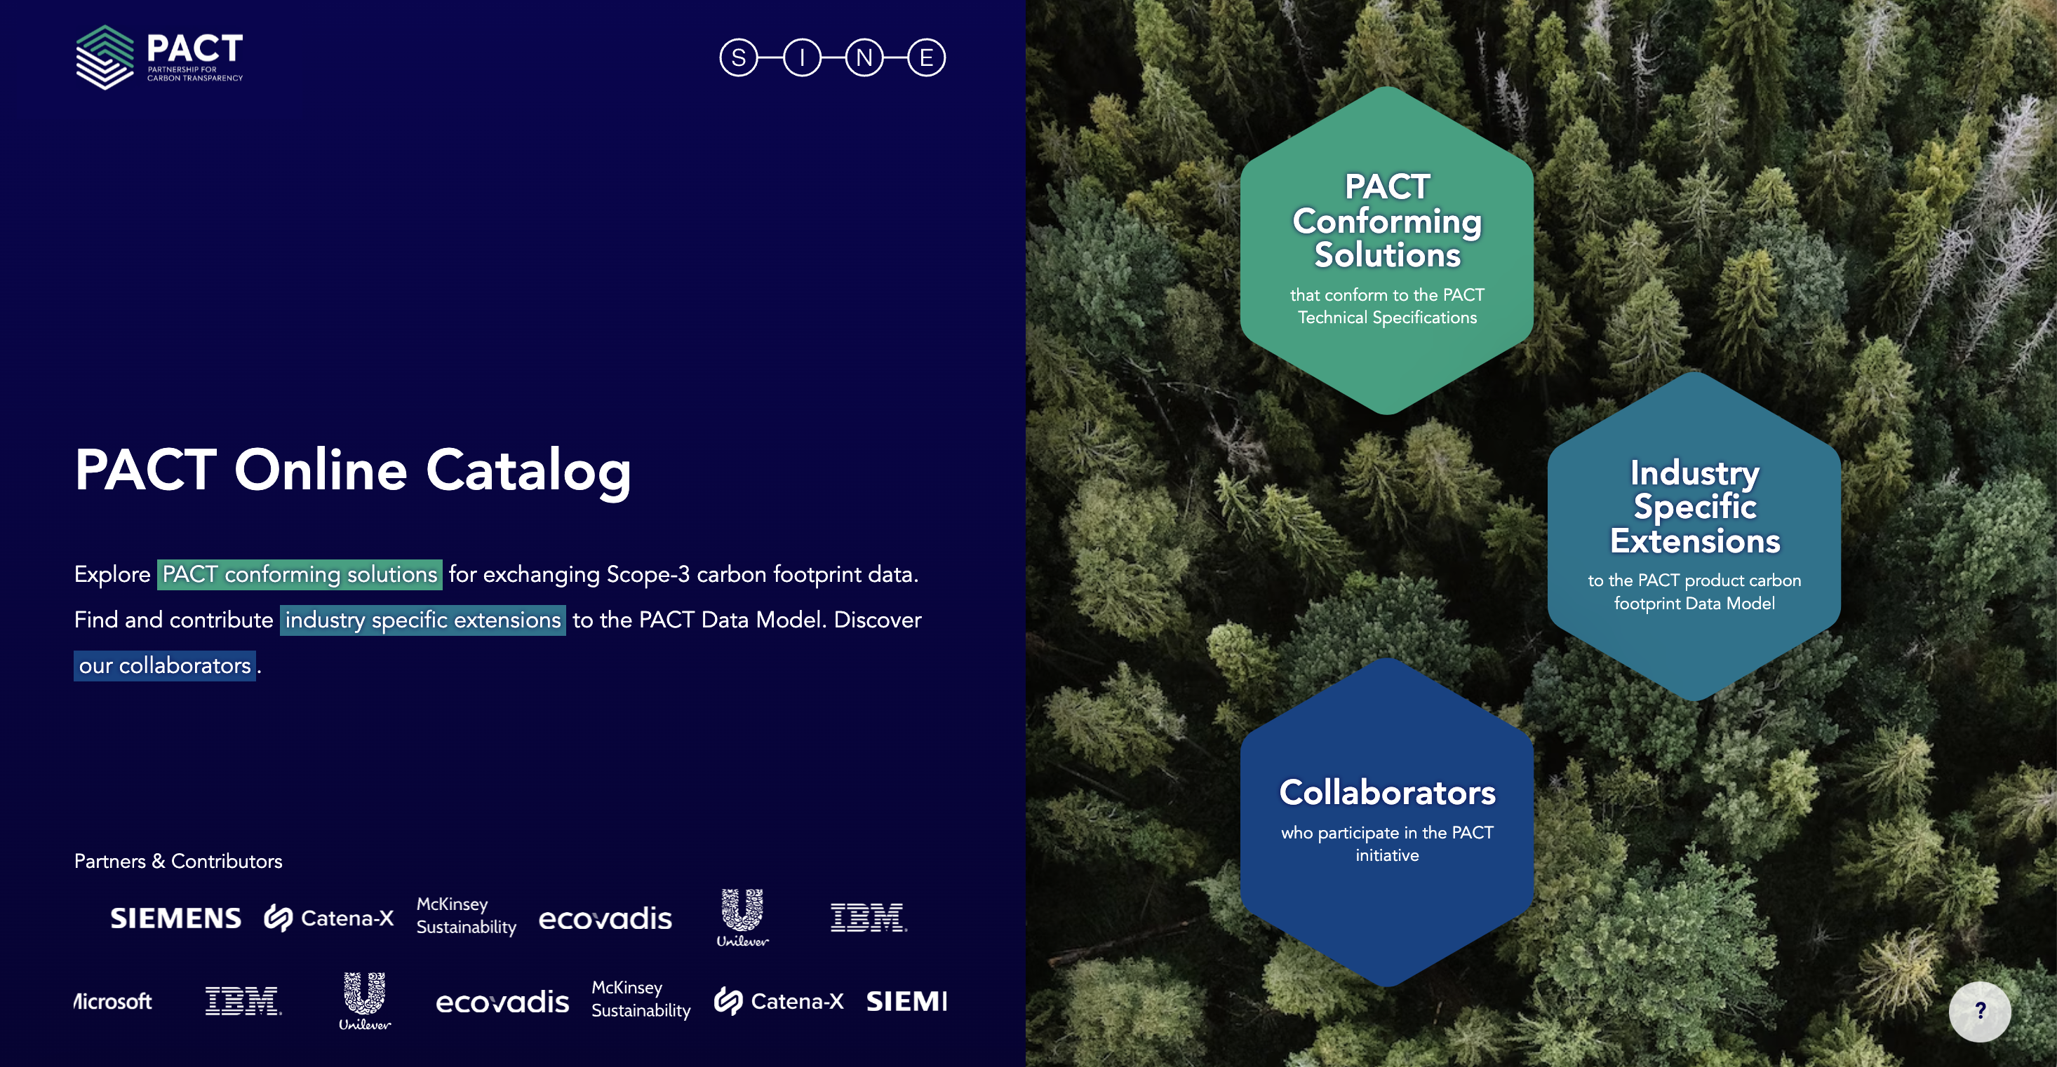](https://pact-catalog.sine.dev/)

Note: This is a link to the Dev/Test environment and is subject to change in future

### **7.3 Publish Conformance Test Results to PACT Online Catalog**

Please refer [this link](https://github.com/sine-fdn/pact-catalog/blob/main/CONTRIB_SOLUTION.md#6-create-a-new-json-file-in-the-conformance-tests-directory) to understand how a Conformance Test result can be uploaded/ published to PACT Online Catalog.